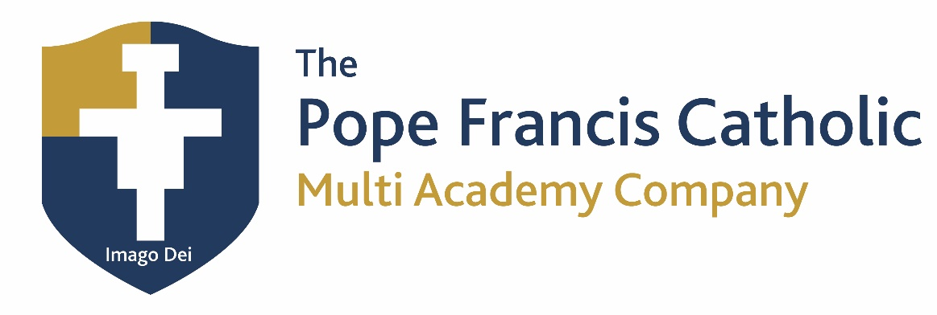

Privacy Notice – Governors and Directors

This privacy notice has been updated in line with UK GDPR.

The categories of governor information that we process include:
- personal identifiers, contacts and characteristics (such as name, date of birth, contact details and postcode)
- governance details (such as role, start and end dates and governor ID)

Why we collect and use governor information
The personal data collected is essential, in order for the school to fulfil their official functions and meet legal requirements.
We collect and use governor information, for the following purposes:
- to meet the statutory duties placed upon us
- to support PFMAC Governor Services

Under the General Data Protection Regulation (GDPR), the legal bases we rely on for processing personal information for general purposes are:
- for the purpose a) named above in accordance with the legal basis of Legal Obligation
- for the purposes b) named above in accordance with the legal basis of Public Task.

All academy trusts, under the Academies Handbook have a legal duty to provide the governance information as detailed above.
In addition, concerning any special category data:
- conditions 2d of GDPR - Article 9

Collecting governor information
We collect personal information via email and application forms.
Governor data is essential for the school’s operational use. Whilst the majority of personal information you provide to us is mandatory, some of it may be requested on a voluntary basis. In order to comply with GDPR, we will inform you at the point of collection, whether you are required to provide certain information to us or if you have a choice in this.

Storing governor information
We hold data securely for the set amount of time shown in our data retention schedule. For more information on our data retention schedule and how we keep your data safe, please visit The Pope Francis Catholic Multi Academy Company - Home (popefrancisacademy.com)

Who we share governor information with
We routinely share this information with:
- the Department for Education (DfE)
- Birmingham Diocesan Education Service (BDES)
- Single Central Register - SCR Tracker

Why we share governor information
We do not share information about our governors with anyone without consent unless the law and our policies allow us to do so. We may share your information within the PFMAC.

Birmingham Diocesan Education Service
The BDES has a legitimate interest because ensuring proper governance of Archdiocesan schools by practising Catholics is one of the legitimate activities of the Archdiocese.

Department for Education
The Department for Education (DfE) collects personal data from educational settings and local authorities.
We are required to share information about our governors with the Department for Education (DfE) under the requirements set out in the Academies Financial Handbook.
All data is entered manually on the GIAS system and held by DfE under a combination of software and hardware controls which meet the current government security policy framework.
For more information, please see ‘How Government uses your data’ section.

Requesting access to your personal data
Under data protection legislation, you have the right to request access to information about you that we hold. To make a request for your personal information, contact your school office.

You also have the right to:
- ask us for access to information about you that we hold
- have your personal data rectified, if it is inaccurate or incomplete
- request the deletion or removal of personal data where there is no compelling reason for its continued processing
- restrict our processing of your personal data (i.e. permitting its storage but no further processing)
- object to direct marketing (including profiling) and processing for the purposes of scientific/historical research and statistics
- not be subject to decisions based purely on automated processing where it produces a legal or similarly significant effect on you
If you have a concern or complaint about the way we are collecting or using your personal data, you should raise your concern with us in the first instance or directly to the Information Commissioner’s Office at https://ico.org.uk/concerns/
For further information on how to request access to personal information held centrally by DfE, please see the ‘How Government uses your data’ section of this notice.

Last updated
We may need to update this privacy notice periodically so we recommend that you revisit this information from time to time. This version was last updated on 21 June 2022.

Contact
If you would like to discuss anything in this privacy notice, please contact: Sarah Sienkiewicz PFMAC Governance Manager: ssienkiewicz@pfmac.org.uk

Alternatively, to make a complaint, please contact our Data Protection Officer:
DPO Service Provider SchoolPro TLC
Primary Contact:
Richard Morley
M: 07779235911
E: rmorley@schoolpro.uk

How Government uses your data
The governor data that we lawfully share with the DfE via GIAS:
- will increase the transparency of governance arrangements
- will enable schools and the department to identify more quickly and accurately individuals who are involved in governance and who govern in more than one context
- allows the department to be able to uniquely identify an individual and in a small number of cases conduct checks to confirm their suitability for this important and influential role

Data collection requirements
To find out more about the requirements placed on us by the Department for Education including the data that we share with them, go to https://www.gov.uk/government/news/national-database-of-governors
Note: Some of these personal data items are not publically available and are encrypted within the GIAS system. Access is restricted to a small number of DfE staff who need to see it in order to fulfil their official duties. The information is for internal purposes only and not shared beyond the department, unless the law allows it.

How to find out what personal information DfE hold about you
Under the terms of the Data Protection Act 2018, you’re entitled to ask the Department:
- if they are processing your personal data
- for a description of the data they hold about you
- the reasons they’re holding it and any recipient it may be disclosed to
- for a copy of your personal data and any details of its source
If you want to see the personal data held about you by the Department, you should make a ‘subject access request’. Further information on how to do this can be found within the Department’s personal information charter that is published at the address below:
https://www.gov.uk/government/organisations/department-for-education/about/personal-information-charter
To contact DfE: https://www.gov.uk/contact-dfe

